Q )

Create a database named “Adamas_University”, and within it, create collections and add the following details inside them:

1. Student_Details: a. Reg No, b. Roll No, c. Name, d. Department, e. Program, f. SGPA

2.Library_Details: • a. ISBN Number, • b. Book Title, • c. Author, • d. Publisher, • e. Issuer Name

# source code

Adamas_University db.createCollection("Student_Details") db.Student_Details.insertMany([

{ "Reg_No": "UG/02/BCA/2023/001", "Roll_No": "001", "Name": "Subhajit Khanda", "Department":

"CSE", "Program": "BCA", "SGPA": 6.75 },

{ "Reg_No": "UG/02/BCA/2023/002", "Roll_No": "002", "Name": "Ruhul Amin Molla", "Department":

"CSE", "Program": "BCA", "SGPA": 6.92 },

{ "Reg_No": "UG/02/BCA/2023/003", "Roll_No":

"003", "Name": "Prabal Mondal", "Department": "CSE",

"Program": "BCA", "SGPA": 6.81 },

{ "Reg_No": "UG/02/BCA/2023/004", "Roll_No":

"004", "Name": "Saptaparni Pal", "Department": "CSE", "Program": "BCA", "SGPA": 6.65 },

{ "Reg_No": "UG/02/BCA/2023/005", "Roll_No":

"005", "Name": "Soumik Ghosh", "Department": "CSE",

"Program": "BCA", "SGPA": 6.73 },

{ "Reg_No": "UG/02/BCA/2023/006", "Roll_No":

"006", "Name": "Srinjoy Sil", "Department": "CSE",

"Program": "BCA", "SGPA": 6.88 },

{ "Reg_No": "UG/02/BCA/2023/007", "Roll_No": "007", "Name": "Saswata Sundar Naskar",

"Department": "CSE", "Program": "BCA", "SGPA": 6.77 },

{ "Reg_No": "UG/02/BCA/2023/008", "Roll_No":

"008", "Name": "Jaya Hore", "Department": "CSE",

"Program": "BCA", "SGPA": 6.96 },

{ "Reg_No": "UG/02/BCA/2023/009", "Roll_No":

"009", "Name": "Haranath Saha", "Department": "CSE",

"Program": "BCA", "SGPA": 8.8 },

{ "Reg_No": "UG/02/BCA/2023/010", "Roll_No":

"010", "Name": "Shri Srimoy Trivedy", "Department":

"CSE", "Program": "BCA", "SGPA": 6.79 }

])

db.createCollection("Library_Details")

Output:

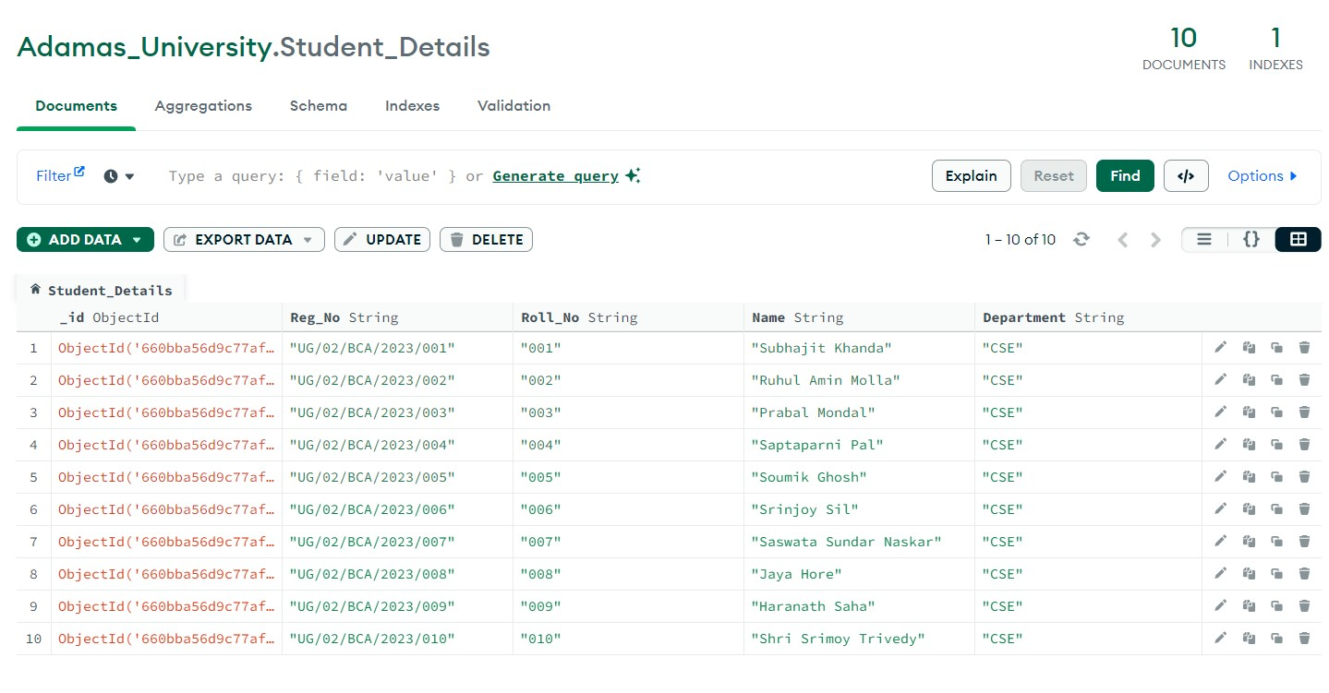

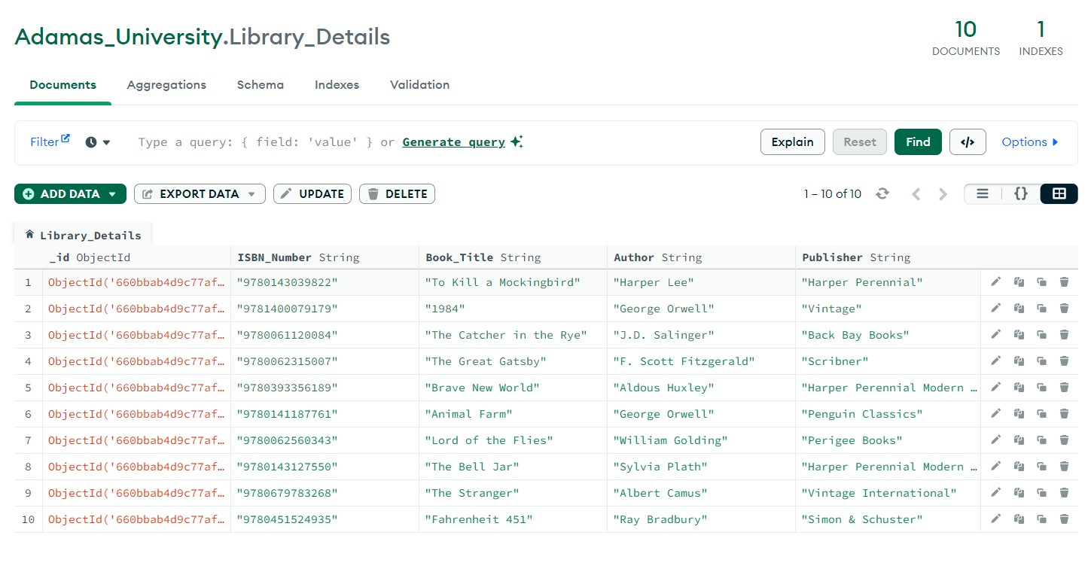

Q )

Create A Database Name “Adamas_University”, And Create Collections And Add Inside Them Store The Following Details(Use list to store name, age, marks individual).

There should be 10 person details. (Use Json Data).

Person_Details: a. Name b. Age c. City d. State

#Source code

Adamas_University db.Person_Details.insertMany([ {

"Name": "John Doe", "Age": 25,

"City": "New York",

"State": "New York"

},

{

"Name": "Alice Smith", "Age": 30,

"City": "Los Angeles",

"State": "California"

},

{

"Name": "Michael Johnson",

"Age": 28,

"City": "Chicago",

"State": "Illinois"

},

{

"Name": "Emily Brown",

"Age": 32,

"City": "Houston",

"State": "Texas"

},

{

"Name": "David Wilson",

"Age": 29,

"City": "Phoenix",

"State": "Arizona"

},

{

"Name": "Emma Martinez",

"Age": 27,

"City": "Philadelphia",

"State": "Pennsylvania"

},

{

"Name": "Matthew Anderson",

"Age": 31,

"City": "San Antonio",

"State": "Texas"

},

{

"Name": "Olivia Garcia",

"Age": 26,

"City": "San Diego",

"State": "California"

},

{

"Name": "Daniel Taylor",

"Age": 33,

"City": "Dallas",

"State": "Texas"

},

{

"Name": "Sophia Hernandez",

"Age": 29,

"City": "San Jose",

"State": "California"

}

]);

Output**:**

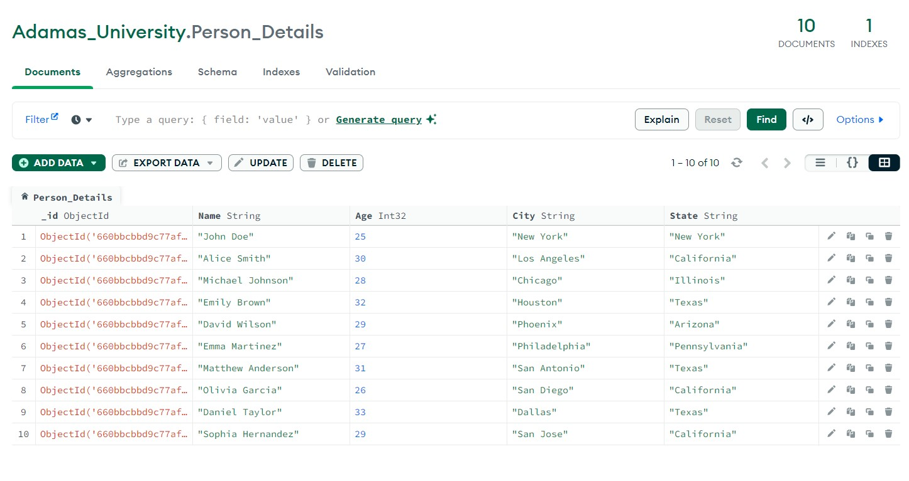

Q )

#Source code

mongosh use Adamas_University db.createCollection("aggregate_few_expressions")

var names = ["Alex", "John", "Bob", "Thomas", "Duke"] var ages = [22, 23, 22, 21, 24] var marks = [99, 100, 96, 95, 98] var salaries = [50000, 60000, 90000, 80000, 70000]

for (var i = 0; i < names.length; i++) { db.aggregate_few_expressions.insertOne({

"Name": names[i],

"Age": ages[i],

"Marks": marks[i],

"Salary": salaries[i]

})

}

Output:

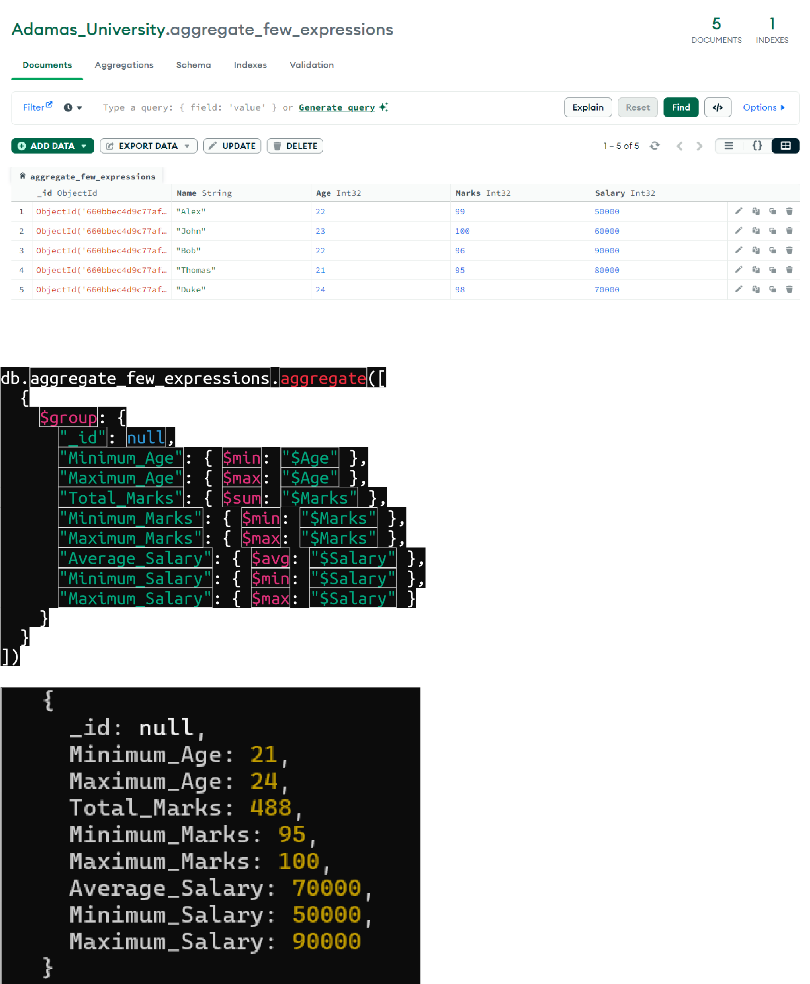

Q )

Write A Query To Get First Two Character Of A Name Attribute.

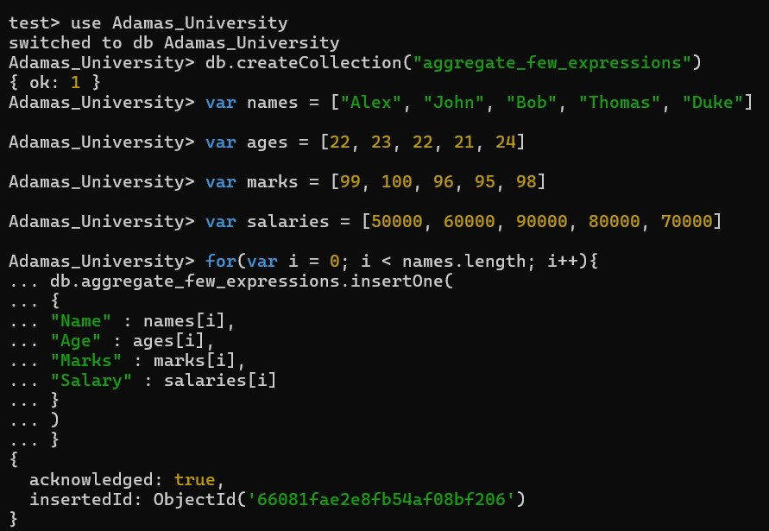

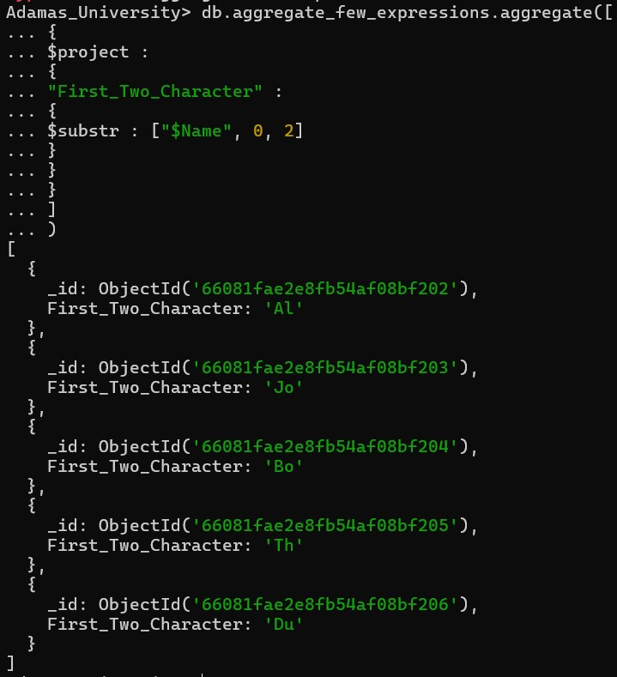

Q )

Display Only The First Character For Customer_Details

Collection

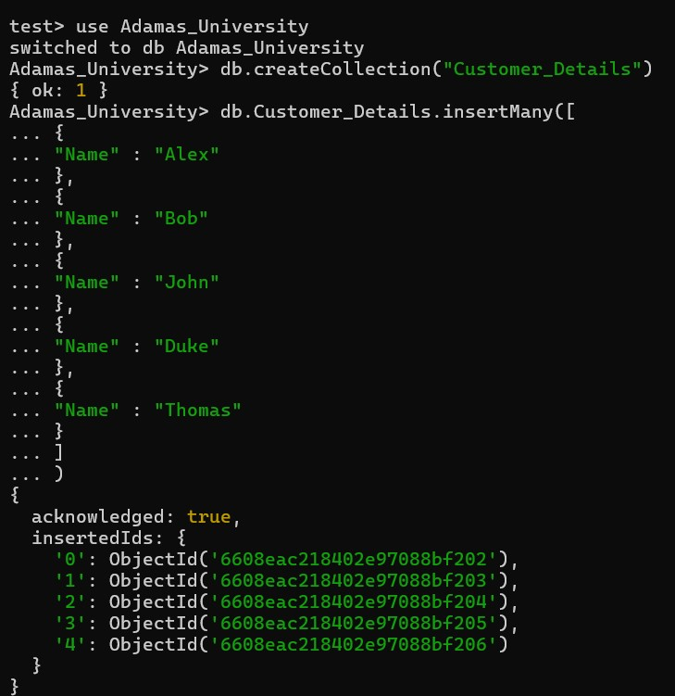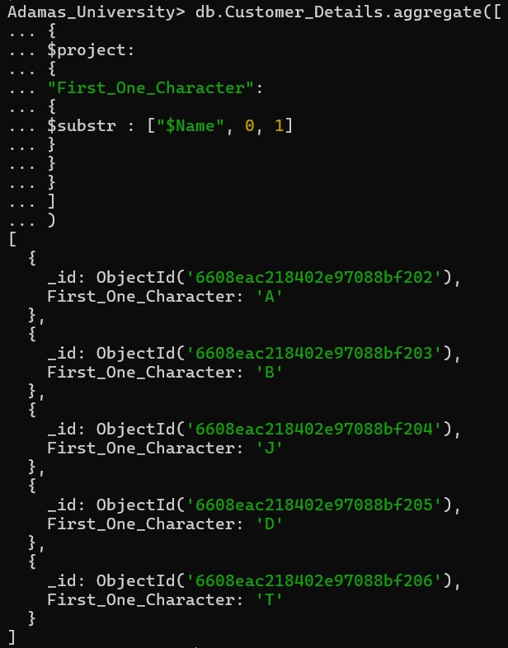

Q )

Update With Price Of All Products By 10% Permanently.

